Expected, Unexpected and Actual Inflation and Interest Rates

- If the expected inflation is 5% and the actual inflation is 3%. Who benefits, lenders or borrowers in fixed loans?

- If the expected inflation is 5% and the actual inflation is 3%. Who benefits, lenders or borrowers in variable rate loans?

- If the expected inflation is 2% and the actual inflation is 3%. Who benefits, lenders or borrowers in fixed loans?

- If the expected inflation is 5% and there is unexpected inflation of 2%. Who benefits, lenders or borrowers in fixed loans?

- If the expected inflation is 2% and there is actual inflation of 2%. Who benefits, lenders or borrowers in fixed loans?

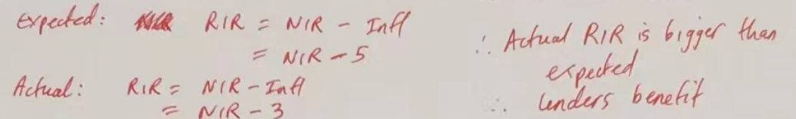
1

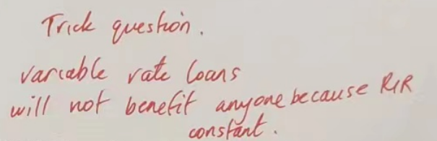
2

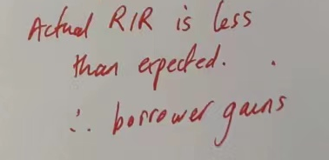
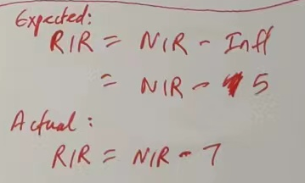

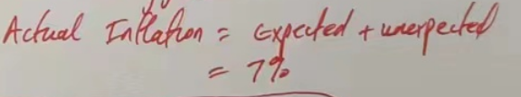
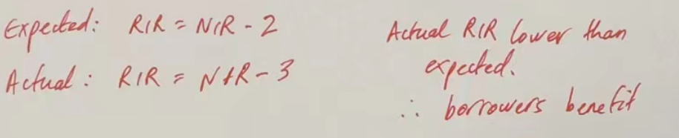
5
4
3

